1. How to create a web page that automatically connects to the server:

* Set up a web server: You need to have a server running on your network that can accept incoming connections from web browsers.

Example:

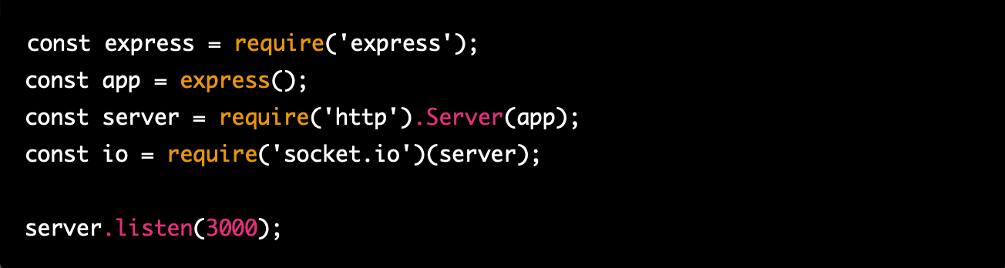

* Create a HTML file: This file will be the foundation of your webpage, and it should include the structure and content of your page.

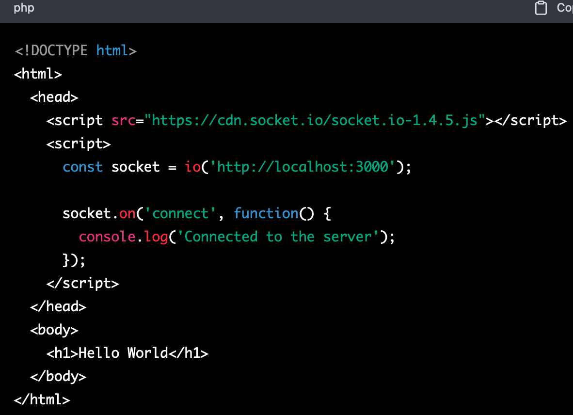

* Add JavaScript code: Use JavaScript to create a web socket connection to your server. You can use the socket.io library to make this process easier.
* Implement server-side logic: On the server side, you need to implement logic that listens for incoming socket connections and handles data exchange between the server and client.

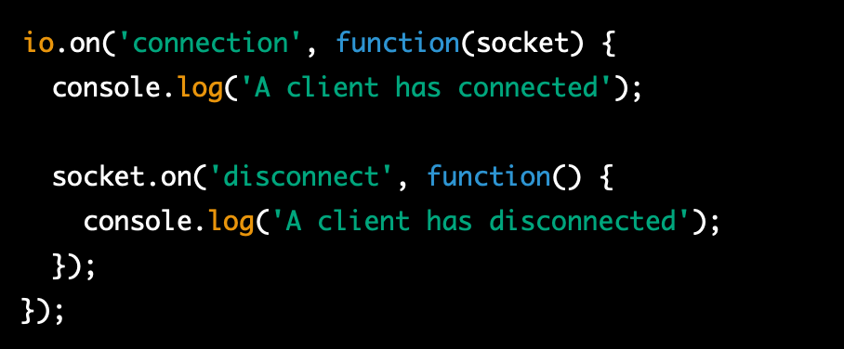

* Test your webpage: Once you've finished writing your code, you can test your webpage by opening it in a web browser and verifying that it connects to the server as expected.

1. Some libraries that can be used for visualization paraview

* Three.js: A JavaScript 3D library that makes it easy to create and render 3D graphics in the browser.
* Pixi.js: A 2D rendering library that is fast and lightweight, making it ideal for creating games and other interactive applications.
* Babylon.js: A powerful and easy-to-use 3D game engine that supports WebGL and WebXR.
* A-Frame: A web framework for building virtual reality experiences that work across desktop, mobile, and VR devices.
* Phaser: A fast, free, and fun open source framework for building HTML5 games that runs on desktop and mobile devices.
* D3.js: A JavaScript library for creating dynamic and interactive data visualizations in the browser.
* Plotly.js: A library for creating beautiful and interactive visualizations that can be used to represent a wide range of data types and formats.

1. npm package

* Paraview-lite
* paraviewweb